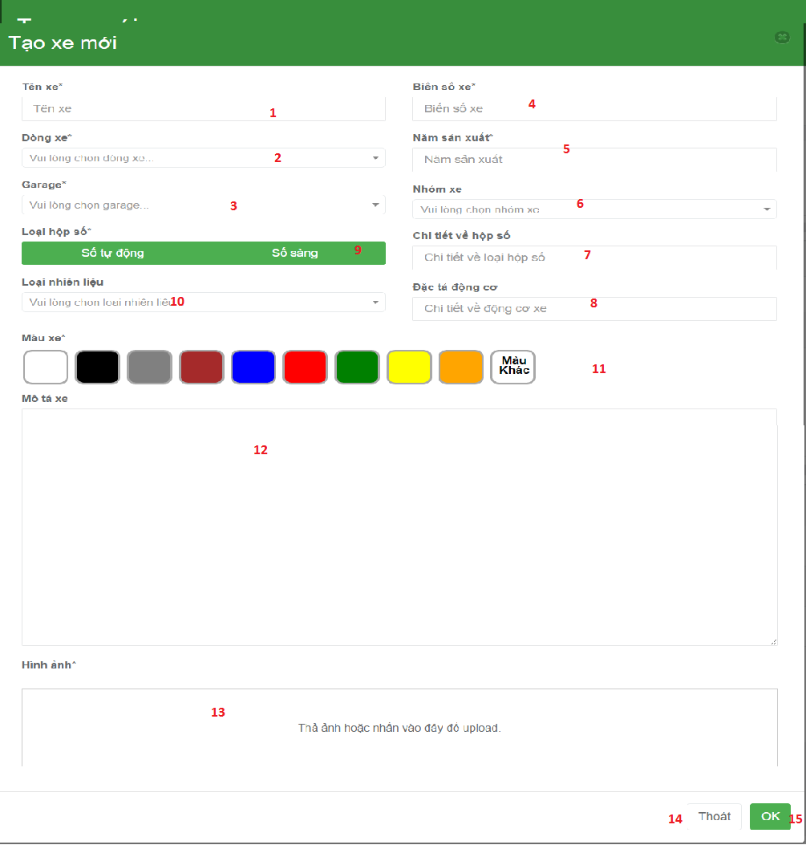

**Fields:**

|  |  |  |  |  |  |  |
| --- | --- | --- | --- | --- | --- | --- |
| No | Field Name | Description | Read Only | Mandatory | Control Type | Data Type |
| 1 | Vehicle name | Allow user input name of vehicle | No | Yes | Tex box | String |
| 2 | Model of vehicle | Allow user choose model of car. | No | Yes | Dropdown | String |
| 3 | Garage of vehicle | Allow user choose garage of vehicle | No | Yes | Dropdown | String |
| 4 | License number of vehicle | Input license number of vehicle | No | Yes | Text Box | String |
| 5 | Year produced of vehicle | Input year of vehicle | No | Yes | Text Box | Number |
| 6 | Vehicle group | Choose vehicle group | Yes | No | Drop down | String |
| 7 | Transition type detail | Input transition type detail | No | No | Text box | String |
| 8 | Engine detail | Input engine detail | No | No | Text box | String |
| 9 | Transition type | Choose transition type | Yes | Yes | Radio button | String |
| 10 | Fuel type | Choose fuel type | Yes | Yes | Drop down | String |
| 11 | Color | Choose color of vehicle | Yes | Yes | Radio button | String |
| 12 | Description | Input description for vehicle | No | No | Text are | String |
| 13 | Images | Input images of vehicle | Yes | Yes | Dropzone | File |

**Buttons/Hyperlinks:**

|  |  |  |  |  |
| --- | --- | --- | --- | --- |
| No | Function | Description | Validation | Outcome |
| 14 | Cancel create new vehicle | Close pop up and cancel command | N/A | Pop up will be hided. |
| 15 | OK | Send command create new vehicle to controler | N/A | Create a new vehicle |